Hotel Booking

Data Analysis Report

* Insights and Recommendations for Business Strategy

#### **Objective**

The primary goal of this analysis is to uncover trends in hotel bookings, cancellations, customer preferences, and revenue-related insights to assist in strategic decision-making.

### **Key Findings**

* 1. **Reservation Status Overview**:
     + **Cancellation Rate**: Approximately 37% of reservations were canceled, indicating potential concerns about customer commitment or booking policies.
     + Visualization: A bar chart comparing the counts of cancelled and not-cancelled bookings.
  2. **Hotel-wise Cancellation Trends**:
     + **City Hotel**: Cancellation rate is 41.7%.
     + **Resort Hotel**: Lower cancellation rate of 27.9%.
     + Suggestion: Investigate factors such as pricing, policies, or customer satisfaction that influence the higher cancellation rate at City Hotels.
     + Visualization: Count plot comparing reservation statuses for City and Resort Hotels.
  3. **Average Daily Rate (ADR) Insights**:
     + **City Hotel** has a higher average ADR compared to Resort Hotel.
     + ADR fluctuations are evident over time, with peaks during certain months, suggesting seasonal demand variations.
     + Visualization: Line chart showing ADR trends for both hotel types.
  4. **Seasonal Booking Trends**:
     + Highest cancellations occur during the summer (June to August), indicating potential overbooking or mismatched expectations during peak seasons.
     + Suggestion: Implement stricter cancellation policies or offer incentives for confirmed bookings.
     + Visualization: Bar chart showing monthly cancellation distribution.
  5. **Top 10 Countries by Cancellations**:
     + Guests from countries like Portugal, the UK, and the USA are among the top contributors to cancellations.
     + Suggestion: Customize marketing and communication strategies for these regions to improve booking retention.
     + Visualization: Pie chart showing the top 10 countries by cancellation percentage.
  6. **Market Segment Analysis**:
     + **Online Travel Agents (OTA)** account for nearly 47% of total reservations but also have the highest cancellation rates.
     + Suggestion: Reassess partnerships with OTAs and evaluate their impact on cancellations versus revenue.
     + Visualization: Bar chart comparing market segments by cancellation proportion.

### **Recommendations**

* 1. **Reduce Cancellation Rates**:
     + Enforce cancellation fees during peak seasons.
     + Offer flexible booking options with incentives for early confirmations.
  2. **Optimize ADR**:
     + Introduce dynamic pricing strategies to capitalize on seasonal demand while maintaining competitiveness.
  3. **Enhance Customer Experience**:
     + Address reasons behind higher cancellation rates for City Hotels through surveys and feedback.
     + Tailor services for high-cancellation regions (e.g., Portugal, UK).
  4. **Focus on Market Segments**:
     + Invest in direct booking channels to reduce dependency on OTAs.
     + Offer loyalty programs to repeat customers for increased retention.

### **Next Steps**

* 1. Share the findings with the marketing and operations teams for actionable strategies.
  2. Conduct further analysis to identify customer segments driving cancellations.
  3. Implement the suggested changes and monitor their impact on key metrics.

Would you like me to refine this text further or add any additional details specific to your visualizations?

### **1. Reservation Status Count**

**Visual**: Bar Chart - Count of Cancelled vs. Not-Cancelled Reservations  
**Insight**: The data reveals that **63% of reservations were not cancelled**, while **37% were canceled**.

* 1. This indicates that nearly one-third of all bookings fail to convert, which is a significant opportunity for improvement.  
     **Actionable Note**: Consider revisiting the cancellation policy or offering discounts for early confirmations.
  2. 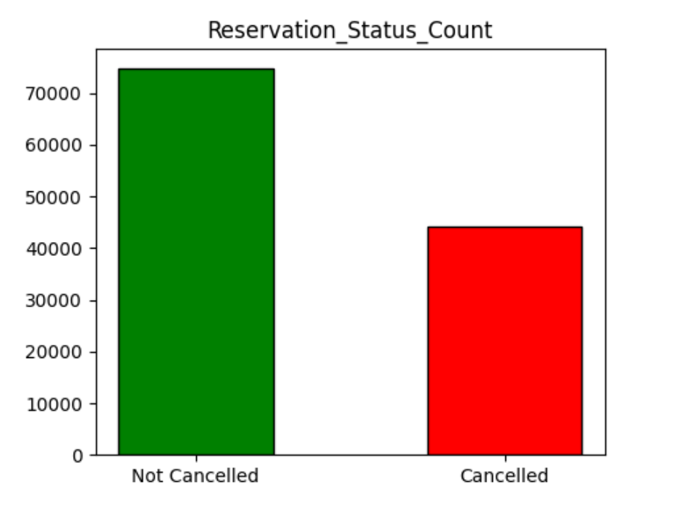

### **2. Reservation Status in Different Hotels**

**Visual**: Count Plot - Reservation Status (Cancelled vs. Not-Cancelled) for City and Resort Hotels  
**Insight**:

* 1. **City Hotels** have a higher cancellation rate (41.7%) compared to **Resort Hotels** (27.9%).
  2. Resort Hotels are better at retaining bookings, which may be linked to customer satisfaction or stricter policies.  
     **Actionable Note**: Investigate why City Hotels face higher cancellations. 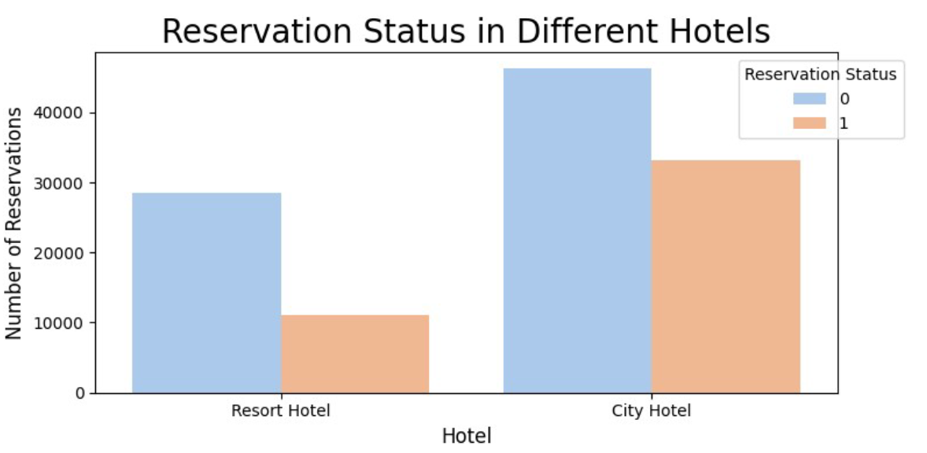Conduct customer surveys or analyze booking conditions.

### **3. Average Daily Rate (ADR) Trends**

**Visual**: Line Chart - ADR Trends for City and Resort Hotels Over Time  
**Insight**:

* 1. ADR fluctuates throughout the year, with City Hotels consistently showing higher ADR compared to Resort Hotels.
  2. The spikes in ADR correspond to peak travel seasons, indicating higher demand.  
     **Actionable Note**: Use dynamic pricing strategies to maximize revenue during peak months while maintaining competitive rates during off-peak seasons.
  3. 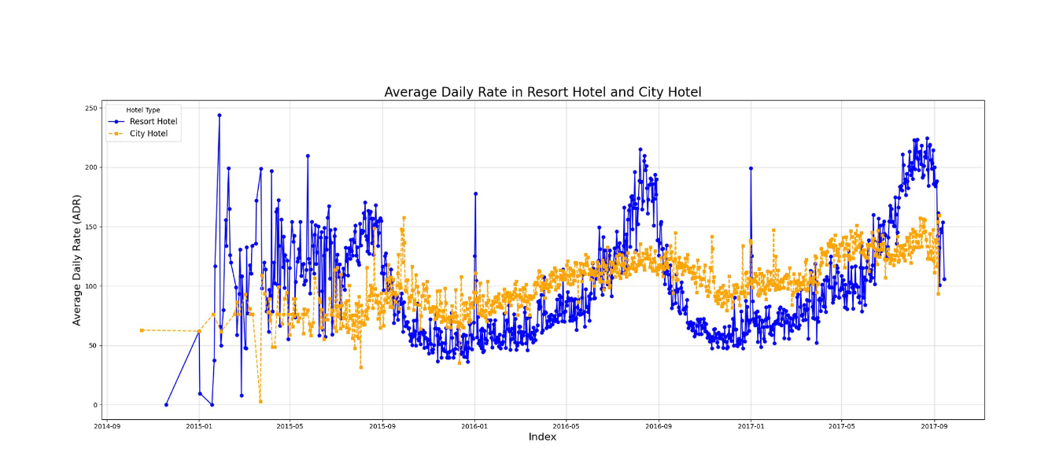

### **4. Reservation Status Per Month**

**Visual**: Bar Chart - Monthly Reservation Status (Canceled vs. Not-Canceled)  
**Insight**:

* 1. The highest number of cancellations occurs in **July and August**, aligning with the summer travel season.
  2. Lower cancellations are observed in the winter months (e.g., January, February).  
     **Actionable Note**: Strengthen retention strategies during the summer, such as prepayment discounts or flexible rescheduling options.

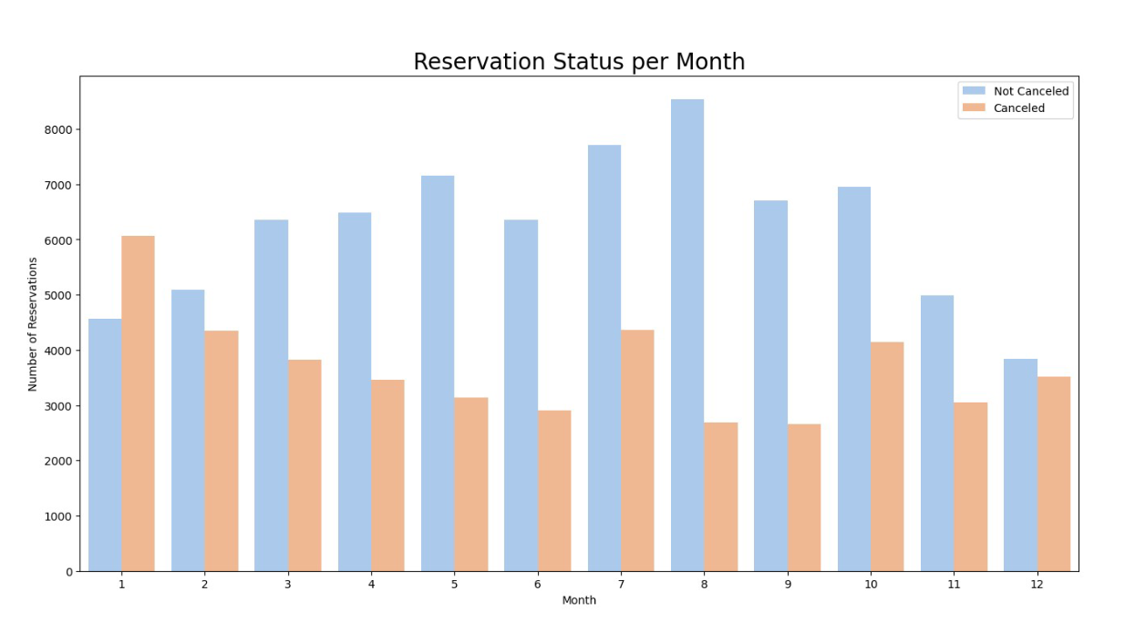

### **5. ADR Per Month (Cancelled Reservations)**

**Visual**: Bar Plot - ADR for Cancelled Reservations by Month  
**Insight**:

* 1. Higher ADR values are associated with canceled reservations in certain months, potentially due to customers canceling expensive bookings.  
     **Actionable Note**: Analyze whether price sensitivity leads to cancellations and offer personalized discounts to high-value customers.
  2. 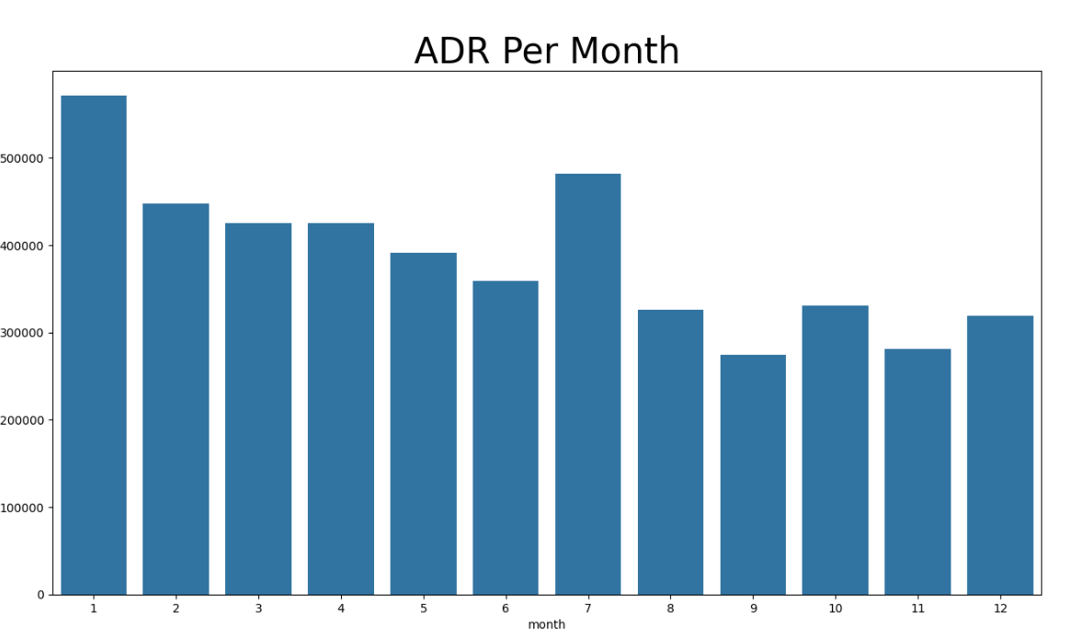

### **6. Top 10 Countries by Reservation Cancellations**

**Visual**: Pie Chart - Top Countries Contributing to Cancellations  
**Insight**:

* 1. Guests from **Portugal, the UK, and the USA** represent the majority of cancellations.
  2. This indicates potential mismatches between customer expectations and the offerings for these regions.  
     **Actionable Note**: Enhance communication and tailor offers to these regions to reduce cancellations.
  3. 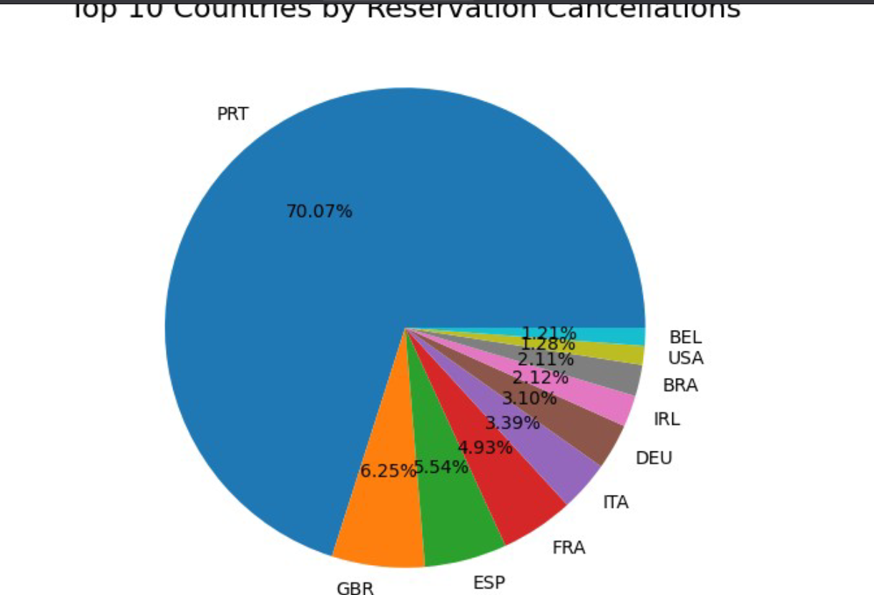

### **7. Market Segment Analysis**

**Visual**: Bar Chart - Distribution of Market Segments and Cancellation Rates  
**Insight**:

* 1. **Online Travel Agents (OTAs)** contribute the most bookings (47%) but also show the highest cancellation rates.
  2. Direct bookings have lower cancellation rates, making them more reliable revenue sources.  
     **Actionable Note**: Encourage direct bookings through loyalty programs, exclusive offers, and better customer engagement.

### **8. ADR Trends for Canceled and Not-Canceled Reservations**

**Visual**: Line Chart - Comparison of ADR for Canceled vs. Not-Canceled Reservations Over Time  
**Insight**:

* 1. **Not-canceled reservations** have a steady ADR trend, whereas **canceled reservations** show irregular spikes.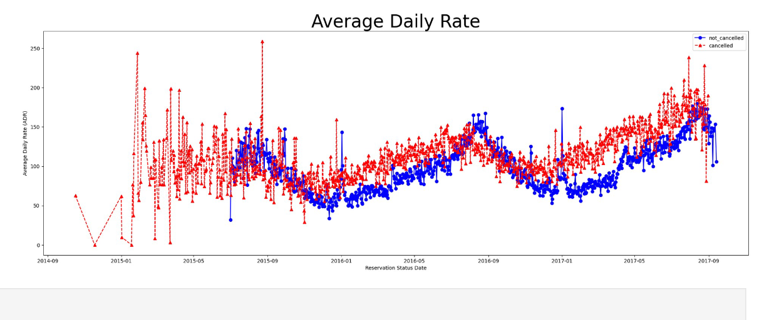
  2. This suggests that high-value bookings are more prone to cancellations.  
     **Actionable Note**: Consider targeting high-value bookings with incentives like flexible payment options or value-added services.
* RECOMMENDATION

• **Reduce Cancellation Rates**:

* Enforce cancellation fees during peak seasons.
* Offer flexible booking options with incentives for early confirmations.

• **Optimize ADR**:

* Introduce dynamic pricing strategies to capitalize on seasonal demand while maintaining competitiveness.

• **Enhance Customer Experience**:

* Address reasons behind higher cancellation rates for City Hotels through surveys and feedback.
* Tailor services for high-cancellation regions (e.g., Portugal, UK).

• **Focus on Market Segments**:

* + Invest in direct booking channels to reduce dependency on OTAs.
  + Offer loyalty programs to repeat customers for increased retention.